**SQL Exercise 2**

**1.Display the Supplier table in the descending order of CITY.**

mysql> select* from supplier

-> order by city DESC;

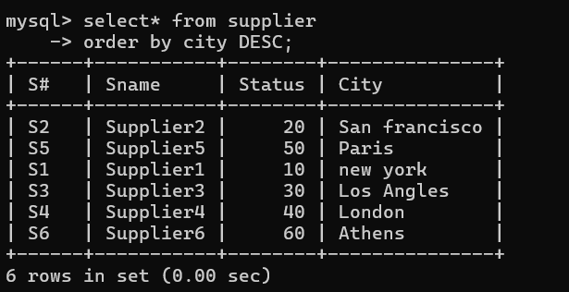

**2. Display the Part Table in the ascending order of CITY and within the city in the ascending order of Part names.**

mysql> select* from parts

-> order by city ASC, pname ASC; 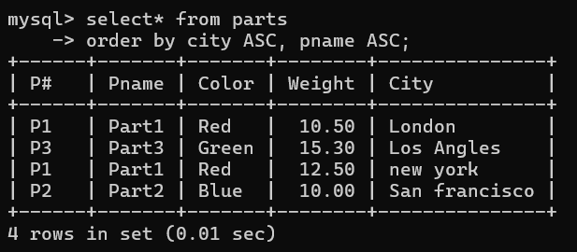

**3. Display all the Suppliers with a status between 10 and 20.**

mysql> select* from supplier

-> where status between 10 and 20;

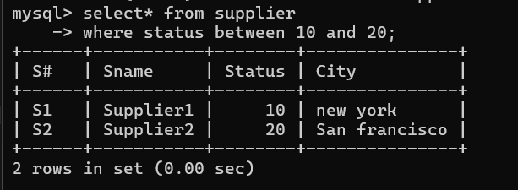

**4. Display all the Parts and their Weight, which are not in the range of 10 and 15.**

mysql> select pname,weight from parts

-> where weight not between 10 and 15;

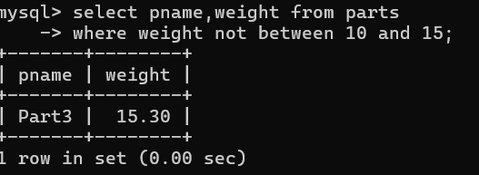

**5. Display all the Part names starting with the letter ‘S’.**

mysql> select pname from parts

-> where pname like 's%';

Empty set (0.00 sec) // as all names starts from p in parts table so empty

**6. Display all the Suppliers, belonging to cities starting with the letter ‘L’.**

mysql> select sname ,city from supplier

-> where city like 'L%';

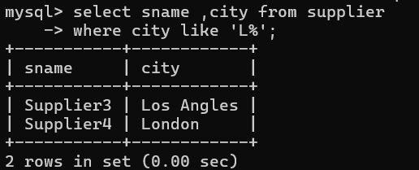

**7. Display all the Projects, with the third letter in JNAME as ‘o’.**

**mysql> select jname, city**

-> from projects

-> where jname like '__o%';

